The 2 sides of an RS232 circuit:
DTE and DCE
The terms DTE and DCE are used in describing communication between devices.
Knowing to which category a device belongs will help on understanding which kind of wire should be used to connect it to any other. Definition DTE or DCE identifies clearly pin-out of the communication plugs and how cables have to be done.
Data Terminal Equipment DTE
Data Communications Equipment DCE
Both acronyms are pronounced by saying the 3 letters.

Typical DTE’s devices are:
Personal Computer, Notebook, Desktop Computer,…
Typical DCE’s devices are:
Modems,… and UPSes.
The new generation of GE Digital Energy • IMV UPSes applies to the standard pin-out of DCE devices, concerning position of signals as Transmission (TD), Reception (RD) and Ground (GND) on a female DB9 plug.
Aim of this document is to give a short explanation about RS232 plugs pin-out and the use of direct or crossed wires; therefore explanation will be focused on RS-232 circuits, even if terms DTE and DCE could be used describing communications other than the serial one.
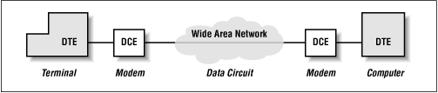
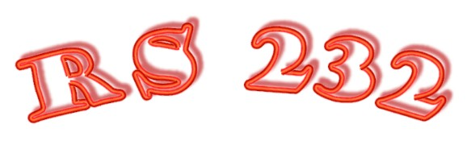
RS-232, now EIA/TIA 232, stands for Recommended Standard, defined on 1969 concerning serial transmission, specifying details about data transmission. Officially called Interface Between Data Terminal Equipment and Data Circuit-Terminating Equipment Employing Serial Binary Data Interchange. It specifies the connector, pin functions, and voltages used to connect two devices together so that they can send data to each other.
- Voltage levels:
Voltage is referenced to a zero-volt ground and ranges from +25 volts to -25 volts. There is a clear distinction, for drivers RS-232, between levels of signals UNLOADED or LOADED, ± 25 Volts for unloaded signals and ± 15 Volts for loaded signals.
Most commonly used levels are ± 12 Volts.
A generic signal could be on “mark” or “space” condition; corresponding voltages are:
Mark equivalent to 0 Volt (TTL GND) between –3 and –15 Volt
Space equivalent to 5 Volt (TTL Vcc) between +3 and +15 Volt
Any signal between +/- 3 Volts is on a not defined status.

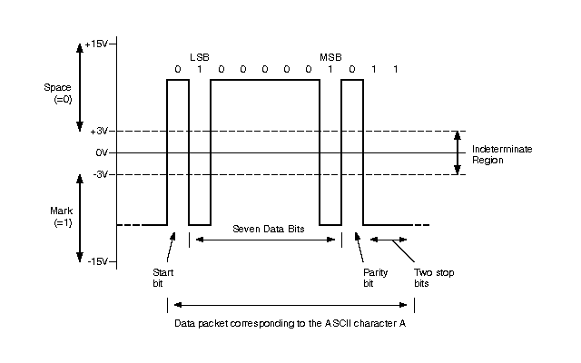

- Baud rate values:
A baud is a signal transition from negative to positive, or positive to negative. In an RS-232 interface there is one binary character encoded during each baud. The term "baud" is often used to mean "bits per second". For the RS-232 standard, it's true that 1bps=1baud, but that's not true for other interconnection technologies. Maximal speed allowed is 115000 bps.
- Shape of the signals that represent '1's and '0's:
If an engineer were using an oscilloscope to observe the signals on an RS-232 line, they would have to comply with a specific set of constraints.
- The specifications for the interface circuitry:
The chipset that transmits the signal is called an RS-232 line driver. The line driver must send a signal that meets the requirements of the standard and that is exactly what the receiver circuitry is expecting. The circuit design parameters for the transmit and receive components are completely specified.
- The purpose for each wire used in the cable:
There are 25 wires described in the RS-232 standard. The purpose of each wire is explicit. Moreover, not all 25 wires are required to make a simple connection between two devices.
Originally a 25-pin connector (called a DB-25) was the most popular. This connector is still in wide use today, mostly on the backs of external modems, printers, or other peripheral devices. A more recent development (since the mid-1980's) has been the introduction of the 9 pin (DB-9) serial connector now found on almost all desktop and notebook computers. Even more recently is the proliferation of PDA's (personal data assistants) with their very simple (often 2-wire) interfaces using tiny phone plugs or other proprietary connectors.
The RS-232 standard doesn't impose any particular connector.
Which are the signals names and functions?
Following lines gives a brief description of the function of each RS-232 signal from the DCE (modem) perspective.

Transmit Data (TD)
The data output line from the DTE. This is the data that will be transmitted to the remote DTE.

Receive Data (RD)
The data input line to the DTE. This is the data received, by the modem, from the remote DTE.

Request To Send (RTS)
An output from the DTE asking if it is allowed to send data to the modem.

Clear To Send (CTS)
An output to the DTE indicating when it is allowed to transmit data to the modem. It tells the DTE to stop sending data, thus preventing buffer overflow.

Data Set Ready (DSR)
An output to the DTE advising that the modem is ready to operate. Sometimes set according to DTR.

Ground (GND)
The common signal ground connection.

Data Carrier Detect (DCD)
An output to the DTE indicating that the modem is receiving a valid carrier signal from the remote modem. (This signal is also called Received Line Signal Detect - RLSD).

Data Terminal Ready (DTR)
An output from the DTE controlling when the modem is allowed to go on-line or answer a call.

Ring Indicator (RI)
An output to the DTE, which toggles on and off as the modem detects an incoming call on the telephone line.
Connectors 25 pin
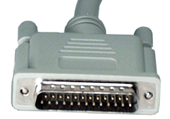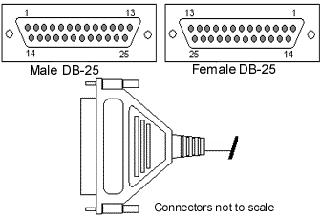
Following pin out description will be done from the perspective of the DTE.
- Pin 2 TD (Transmit data) to DCE
- Pin 3 RD (Receive data) from DCE
- Pin 4 RTS (Request To Send) to DCE
- Pin 5 CTS (Clear To Send) from DCE
- Pin 6 DSR (Data Set Ready, DCE ready) from DCE
- Pin 7 GND (Ground)
- Pin 8 CD/DCD (Data Carrier Detect) from DCE
- Pin 20 DTR (Data Terminal Ready, DTE ready) to DCE
- Pin 22 RI (Ring Indicator) from DCE

Connectors 9 pin
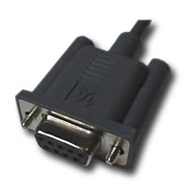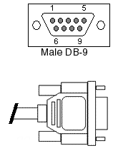
Following pin out description will be done from the perspective of the DTE.
- Pin 2 RD (Receive Data) from DCE
- Pin 3 TD (Transmit Data) to DCE
- Pin 4 DTR (Data Terminal Ready, DTE ready) to DCE
- Pin 5 GND (Signal Ground)
- Pin 6 DSR (Data Set Ready, DCE ready) from DCE
- Pin 7 RTS (Request To Send) to DCE
- Pin 8 CTS (Clear To Send) from DCE
- Pin 9 RI (Ring Indicator) from DCE

Important to note that pin-out position of the signals RD and TD has been reversed, changing from DB25 to DB9 plugs. This could create confusion.

Common RS-232 cable wirings
This document includes information how to make common wires for RS-232 connections. I have shown pin-outs for standard 25-pin connection and de-facto 9-pin connector used in PCs.

Normal DTE-DCE connection
These wirings can be used with normal Data Terminal Equipment (DTE) to Data Communications Equipment (DCE) connections. The wirings are standard way to do asynchronous DTE to DCE connection and they support hardware handshaking. Good wires for PC to modem connections. 9-pin to 25-pin wiring can also be used for making 9-pin to 25-pin connector adapters.

DTE (25 pin) DCE (25 pin)

TD 2 ------------------------> 2 RD
RD 3 <------------------------ 3 TD
RTS 4 ------------------------> 4
CTS 5 <------------------------ 5
DSR 6 <------------------------ 6
DCD 8 <------------------------ 8
DTR 20 ------------------------> 20
SG 7 ------------------------- 7
RI 22 <------------------------ 22

DTE (9 pin) DCE (25 pin)

TD 3 ------------------------> 2 RD
RD 2 <------------------------ 3 TD
RTS 7 ------------------------> 4
CTS 8 <------------------------ 5
DSR 6 <------------------------ 6
DCD 1 <------------------------ 8
DTR 4 ------------------------> 20
SG 5 ------------------------- 7
RI 9 <------------------------ 22

DTE(9 pin) DCE (9 pin)

DCD 1 <------------------------ 1
RD 2 <------------------------ 2 TD
TD 3 ------------------------> 3 RD
DTR 4 ------------------------> 4
GND 5 ------------------------- 5
DSR 6 <------------------------ 6
RTS 7 ------------------------> 7
CTS 8 <------------------------ 8
RI 9 <------------------------ 9

Two-wire DTE-DCE wiring
This wiring can be used between DTE and DCE where hardware handshaking is not needed.

DTE (25 pin) DCE (25 pin)

TD 2 ------------------------> 2 RD
RD 3 <------------------------ 3 TD
RTS 4 ----┐ ┌----> 4
CTS 5 <---┘ └----- 5
DSR 6 <---┐ ┌----- 6
DCD 8 <---┤ ├----- 8
DTR 20 ----┘ └----> 20
SG 7 ------------------------- 7

DTE (9 pin) DCE (25 pin)

TD 3 ------------------------> 2 RD
RD 2 <------------------------ 3 TD
RTS 7 ----┐ ┌----> 4
CTS 8 <---┘ └----- 5
DSR 6 <---┐ ┌----- 6
DCD 1 <---┤ ├----- 8
DTR 4 ----┘ └----> 20
SG 5 ------------------------- 7

DTE (9 pin) DCE (9 pin)

TD 3 ------------------------> 3 RD
RD 2 <------------------------ 2 TD
RTS 7 ----┐ ┌---> 7
CTS 8 <---┘ └---- 8
DSR 6 <---┐ ┌---- 6
DCD 1 <---┤ ├---- 1
DTR 4 ----┘ └---> 4
SG 5 ------------------------- 5

Null modem cable
This cable can be used when you must connect two DTE equipments like computers to each other directly without using any data communication equipment in between computers. This wiring supports hardware handshaking.

DTE (25 pin) DTE (25 pin)

TD 2 ------------------------> 3 RD
RD 3 <------------------------ 2 TD
RTS 4 ------------------------> 5 CTS
CTS 5 <------------------------ 4 RTS
DSR 6 <---┬-------------------- 20 DTR
DCD 8 <---┘ ┌---> 8 DCD
DTR 20 --------------------┴---> 6 DSR
SG 7 ------------------------- 7 SG

DTE (25 pin) DTE (9 pin)

TD 2 ------------------------> 2 RD
RD 3 <------------------------ 3 TD
RTS 4 ------------------------> 8 CTS
CTS 5 <------------------------ 7 RTS
DSR 6 <---┬-------------------- 4 DTR
DCD 8 <---┘ ┌----> 1 DCD
DTR 20 -------------------┴----> 6 DSR
SG 7 ------------------------- 5 SG

DTE (9 pin) DTE (9 pin)

RD 2 <------------------------ 3 TD
TD 3 ------------------------> 2 RD
RTS 7 ------------------------> 8 CTS
CTS 8 <------------------------ 7 RTS
DSR 6 <---┬-------------------- 4 DTR
DCD 1 <---┘ ┌---> 1 DCD
DTR 4 --------------------┴---> 6 DSR
SG 5 ------------------------- 5 SG

Two-wire DTE-DTE connection
This cable can be used when you must connect two DTE equipments like computers to each other directly without using any data communication equipment between computers. This wiring needs only two signal wires and ground between computers but does not support hardware handshaking.

DTE (25 pin) DTE (25 pin)

TD 2 ------------------------- 3 RD
RD 3 <-----------------------> 2 TD
RTS 4 ----┐ ┌----- 4
CTS 5 <---┘ └----> 5
DSR 6 <---┐ ┌----> 6
DCD 8 <---┤ ├----> 8
DTR 20 ----┘ └----- 20
SG 7 ------------------------- 7

DTE (25 pin) DTE (9 pin)

TD 2 ------------------------- 2 RD
RD 3 <-----------------------> 3 TD
RTS 4 ----┐ ┌----- 7
CTS 5 <---┘ └----> 8
DSR 6 <---┐ ┌----> 6
DCD 8 <---┤ ├----> 1
DTR 20 ----┘ └----- 4
SG 7 ------------------------- 5

DTE (9 pin) DTE (9 pin)

TD 3 ------------------------- 2 RD
RD 2 <-----------------------> 3 TD
RTS 7 ----┐ ┌----- 7
CTS 8 <---┘ └----> 8
DSR 6 <---┐ ┌----> 6
DCD 1 <---┤ ├----> 1
DTR 4 ----┘ └----- 4
SG 5 ------------------------- 5

