SNMP card for SitePro series 6 and LanPro 33
Getting started
Advanced SNMP card is a plug-in card to present UPS information on the network, suitable just for over mentioned UPS models, whose communication protocol is the new IMV one, different from the previous single phase (CP4) or three phase (IMT).
In line with the IMV bus concept, more than one SNMP card could be installed on the same UPS, therefore some hardware settings need to be adjusted before installing it on the unit.
By the way, the device is delivered with a manual, which describes jumper position and configuration.
Once the card is installed and powered, if communication with the UPS is OK, the green LED on the front plate must blink once per second.

Configuration:

SNMP card can be configured, as well as the previous model, by a console serially connected or remotely using TELNET.
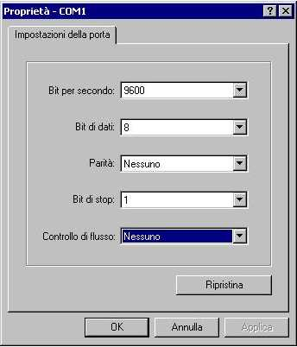
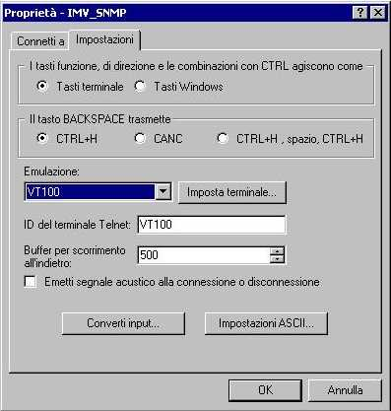
Serial configuration:
Using terminal emulator connect a 1:1 cable to the 9 pin plug of the card, configuration of the emulator (HyperTerminal) as follows: 9600bps, 8 bit, 1 stop bit, no parity no flow control and terminal emulation VT100.
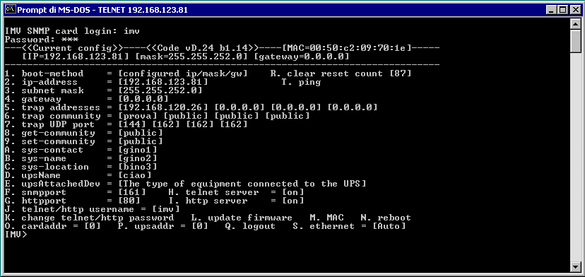
Press X to access the configuration menu of the SNMP card.
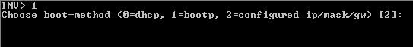
Default setting on the SNMP card enables the DHCP boot method; therefore the card will retrieve an address from the DHCP server and will let the IMV UPS data available on the network. Anyway, of course, any of the available parameter could be modified. Most important parameters to have the device active on the network are IP address and subnet mask.
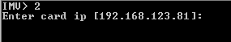
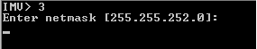
If a fixed IP address has to be stored on the SNMP card, first the boot method has to be changed to 2.
Type 1 [Enter], then type 2 [Enter] to select configured values
To store a fixed IP address
Type 2 [Enter], then enter the desired address nnn.nnn.nnn.nnn
To store a subnet mask different than the C class default one,

Type 3 [Enter] and write the new mask nnn.nnn.nnn.nnn To store a gateway address
Type 4 [Enter] and the address nnn.nnn.nnn.nnn
The parameter over mentioned are the most important ones in order to have the SNMP card properly working on the network environments.
Other available settings are:
Ethernet connections S 0=auto is the default, otherwise each of the available could be selected
Reboot N to reboot the AGENT

Configuration menu could also be accessed using TELNET. This way, user will be prompt to a username and password request. Default values are imv.
All other parameter could then be modified as described.
Once remote configuration is completed user must log-out (Q) or reboot (N).

